**IBM - Nalaiya Thiran Project**

**Assignment 1 Smart Home**

**Vanathi.M**

**812019106040**

## Circuit Diagram:

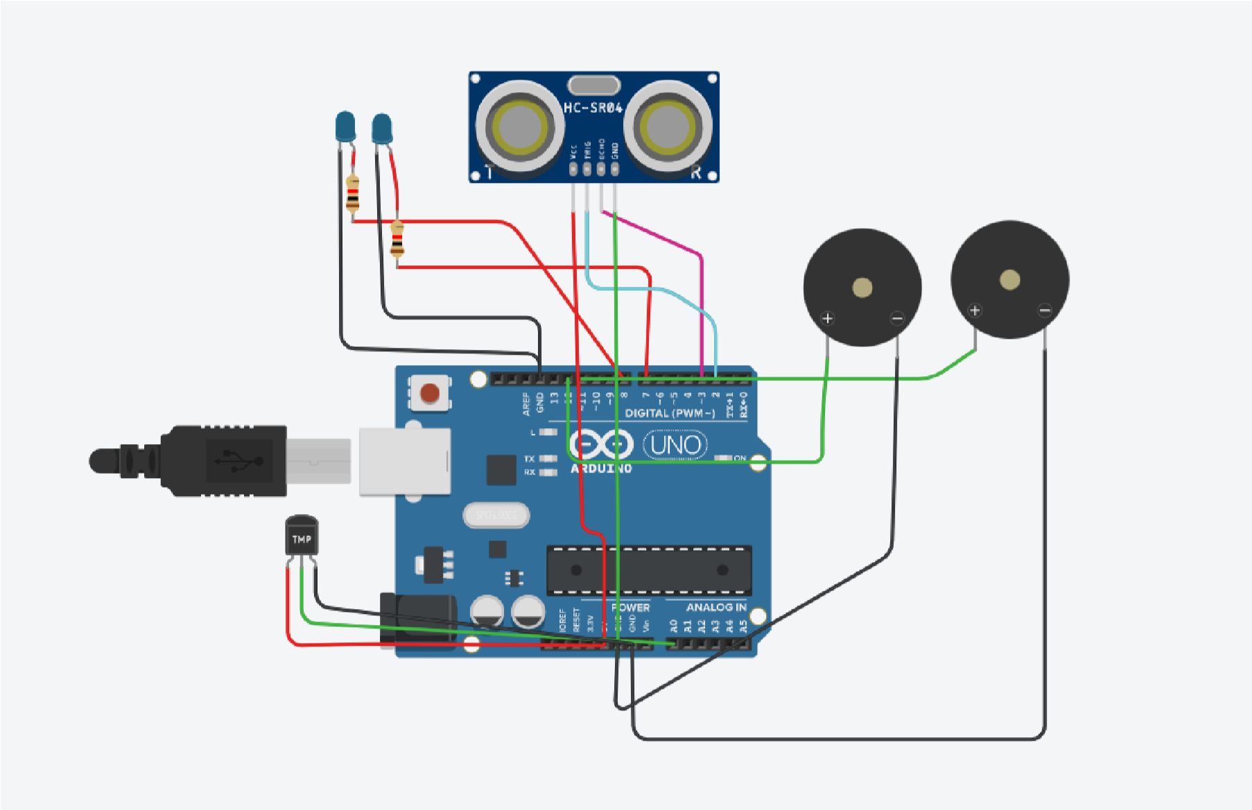

## Source Code :

int t=2;

int e=3;

void setup()

{

Serial.begin(9600);

pinMode(t,OUTPUT);

pinMode(e,INPUT);

pinMode(12,OUTPUT);

}

void loop() { //ultrasonic sensor digitalWrite(t,LOW); digitalWrite(t,HIGH); delayMicroseconds(10); digitalWrite(t,LOW); float dur=pulseIn(e,HIGH); float dis=(dur*0.0343)/2; Serial.print("Distance is: ");

Serial.println(dis);

//LED ON

if(dis>=60)//(in terms of centimeter)

{

digitalWrite(8,HIGH); digitalWrite(7,HIGH);

}

//Buzzer For ultrasonic Sensor if(dis>=60)

{

for(int i=0; i<=5; i=i+1)

{ tone(12,i); delay(1000); noTone(12);

delay(1000);

}

}

//Temperate Sensor double a= analogRead(A0); double t=(((a/1024)*5)-0.5)*100;

Serial.print("Temp Value: "); Serial.println(t);

delay(1000);

//LED ON

if(t>=20)//(in terms of celsius)

{

digitalWrite(8,HIGH); digitalWrite(7,HIGH);

}

//Buzzer for Temperature Sensor

if(t>=20)

{

for(int i=0; i<=5; i=i+1)

{ tone(12,i); delay(1000); noTone(12); delay(1000);

}

}

//LED OFF if(t<20)

{

digitalWrite(8,LOW); digitalWrite(7,LOW);

} }

## Output:

# • Serial Monitor:

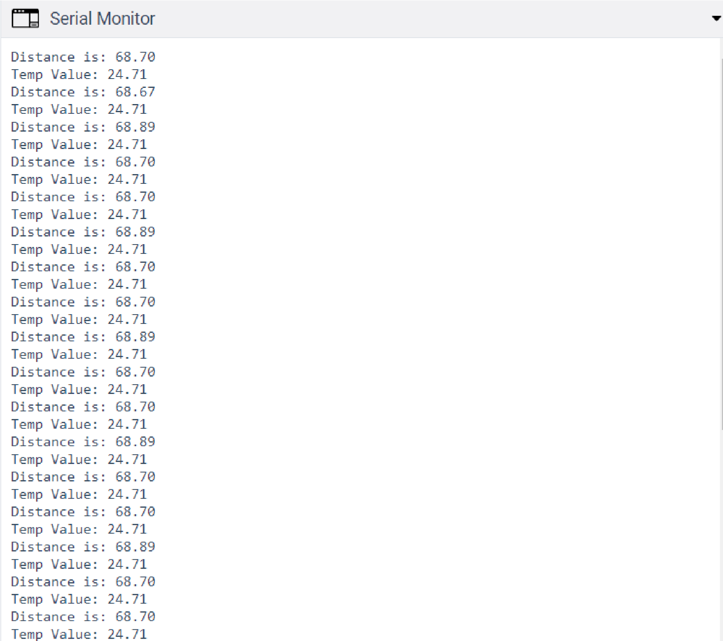

# • Circuit Diagram:

